**Module 21 Neural Network Analysis**

**Overview of the analysis: Explain the purpose of this analysis.**

* The purpose of this analysis is to provide insight into the best possible candidates for the nonprofit organization Alphabet Soup to select for funding their ventures. We are attempting to create a model and train it to identify the best applicants from their pool.

**Results: Using bulleted lists and images to support your answers, address the following questions:**

**Data Preprocessing**

**What variable(s) are the target(s) for your model?**

* IS_SUCCESSFUL is the target of the model, with a 1 meaning prior funding was successfully completed 0 meaning failed/ incomplete.

**What variable(s) are the features for your model?**

* IS_SUCCESSFUL is also the column chosen for the data.

**What variable(s) should be removed from the input data because they are neither targets nor features?**

* NAME and EIN were removed from the data because they are neither targets nor features.

**Compiling, Training, and Evaluating the Model**

**How many neurons, layers, and activation functions did you select for your neural network model, and why?**

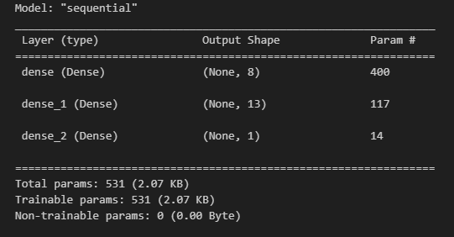

**Were you able to achieve the target model’s performance?**

* I was unable to achieve the required 75% accuracy score required, of my three attempts the picture on the previous page has the closest score of 72.71%

**What steps did you take in your attempts to increase model performance?**

* During the Compile/Training/Evaluate phase I tried multiple types of activation types as well as multiple amounts of layers and units. The last method I tried was to manipulate the number of epochs used per run. However, no amount of changing the variables returned a successful run.

**Summary: Summarize the overall results of the deep learning model. Include a recommendation for how a different model could solve this classification problem, and then explain your recommendation.**

* The best results I could create seemed to rely on the “relu” and “sigmoid” activations. In the future I would recommend trying to manipulate the data a little more before testing and trying to reduce the number of columns. I also think that perhaps using a lower amount of epoch could be effective in raising the accuracy of the model.